You will need a low-cost J-Link flashing tool to flash a DA58-D PCB:

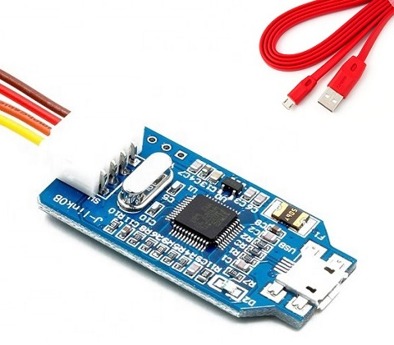

Now please connect J-Link to a DA58-D PCB. You don’t need to connect any power supply, the PCB will be supplied from the J-Link tool!

Standard pinout of the J-Link:

|  |  |  |  |
| --- | --- | --- | --- |
| **1** | **2** | **3** | **4** |
| VCC | SWDIO | SWCLK | GND |

This pinout is pin-to-pin compatible with a pinout of a flashing socket on the PCB.

The VCC pin on the PCB is the closest pin to a big capacitor at the edge of the board:

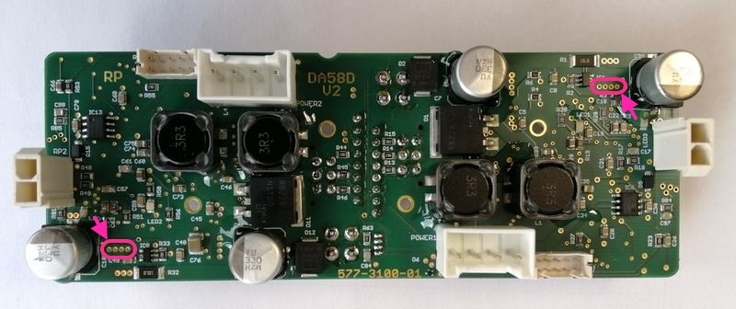

Start J-Flash software and choose existing project **atmel.jflash** at the start screen:

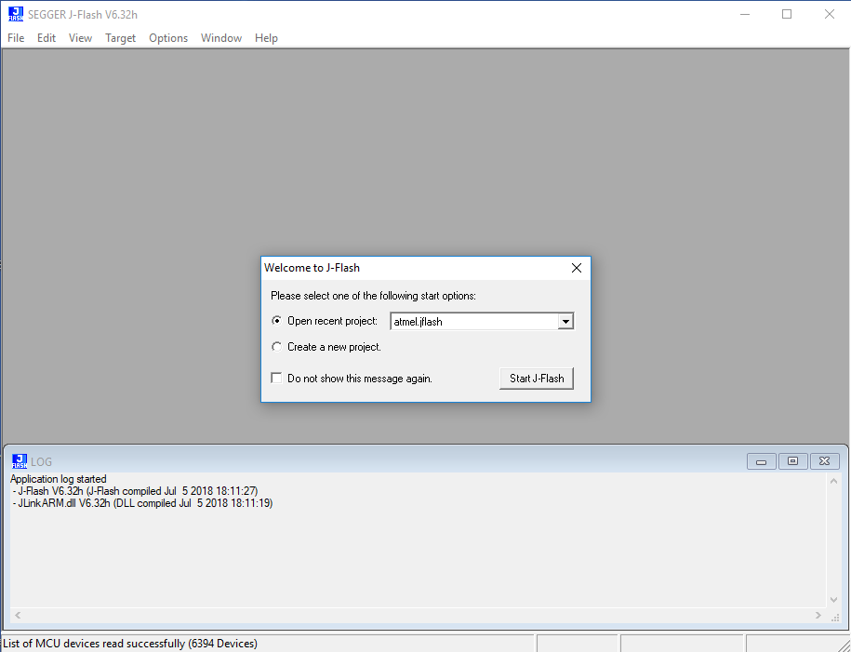

Now establish connection with a MCU (Target -> Connect):

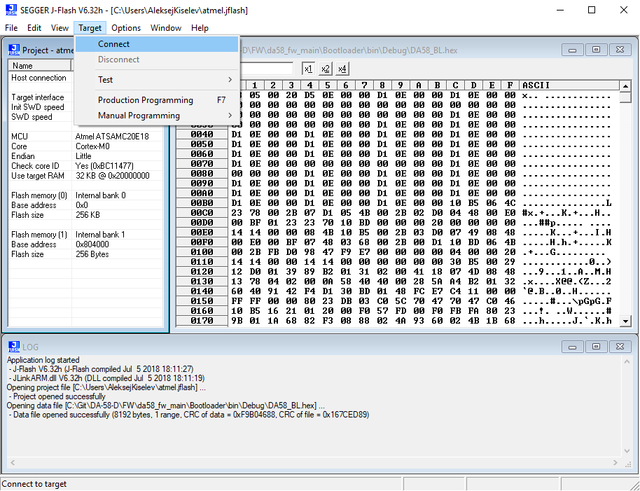

Start flashing firmware (Target - > Production Programming):

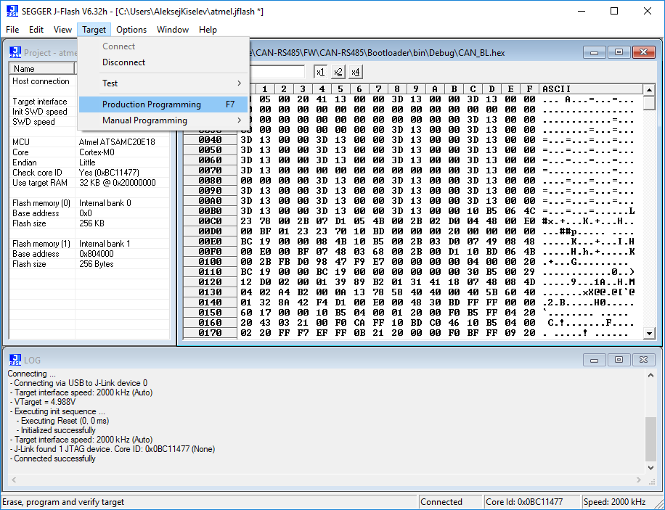

You will get a message about successful programming afterwards:

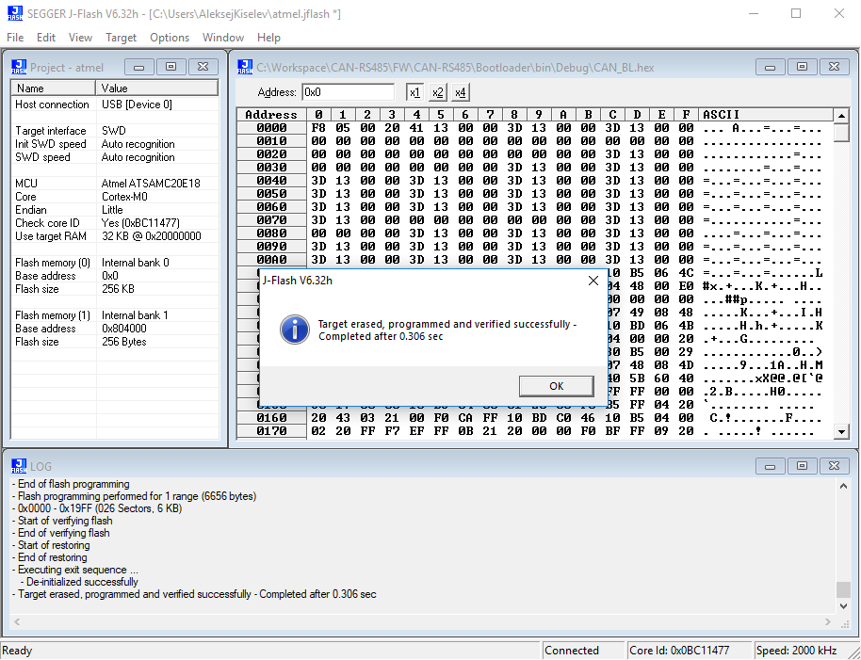

Now disconnect the software (Target -> Disconnect):

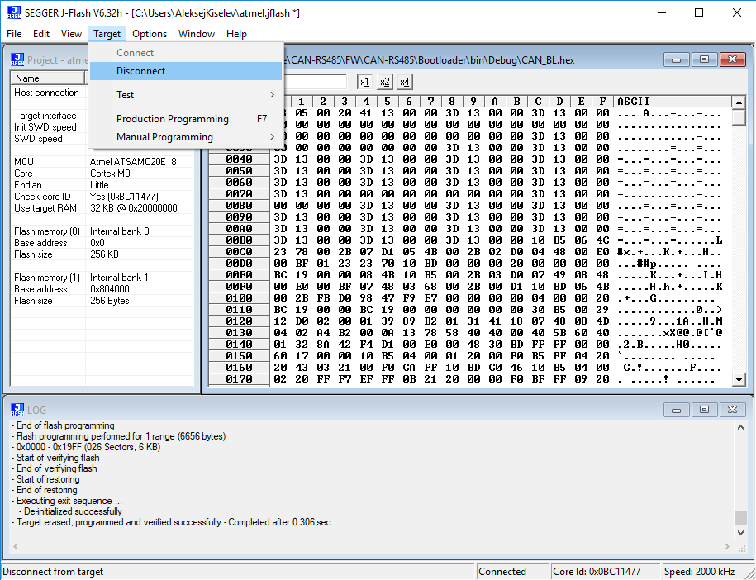

We have 2 processors onboard, so you have to repeat the sequence for the second part of the PCB.

After the successful flashing of both sides you can remove the J-Link tool, connect power supply and data cables, start the bootloader software and try to update a firmware:

